-PRESS RELEASE-

Morelia, Michoacán, September 24, 2020.

The 18th FICM will present a program dedicated to Gilberto Martínez Solares

The Morelia International Film Festival (FICM), with the invaluable support of Fundación Televisa and Cineteca Nacional, will present a program dedicated to Mexican director Gilberto Martínez Solares during its 18th edition. The prolific director made more than 150 films from 1938 to 1979, many of them big box office wins.

His magnificent body of work in film was not limited to directing. In his early days, he was also a star photographer, stillman, lighting tech, camera operator and cinematographer. Later, he became the scriptwriter for at least half of the films he directed and some more directed by other colleagues, as well as being an occasional actor and producer with his company, Frontera Films, alongside his son Adolfo.

“No other director understood the tastes of the general public like Don Gilberto. Even in moments of great crisis in national cinema, his films made profits and enjoyed enormous popularity ”, writes curator Héctor Orozco, from Fundación Televisa.

The program dedicated to Gilberto Martínez Solares will present Santo y Blue Demon contra los monstruos (1970) and a copy of Calabacitas tiernas (1949) that's been restored by Fundación Televisa in collaboration with the Cineteca Nacional, .

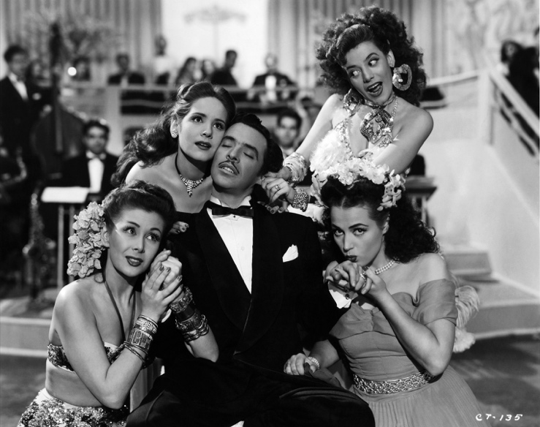
Calabacitas tiernas | Colección y Archivo, Fundación Televisa

Additionally, a phoot exhibit dedicated to Gilberto Martínez Solares will be presented during the 18th FICM in collaboration with Fundación Televisa, at the Andador Hidalgo in the Plaza Benito Juárez, in Morelia.

Press contact:
Margarita Fink
margarita.fink@moreliafilmfest.com
Cel. 04455-5405-9998
More information:
www.moreliafilmfest.com
Facebook: moreliafilmfest
Twitter: @FICM
#FICM2020
#MoreliaEsCineMexicano

