-PRESS RELEASE-

Michoacán, Morelia, September 10, 2019

Urban artist Alter Os created a mural for the 17th FICM

For the 17th Morelia International Film Festival (FICM) urban artist Omar Arias, better known as Alter Os, designed a mural inspired by this edition’s official image which was created by Rodrigo Toledo.

The mural, painted on one of the walls in Casa Picnic, which is located in Circuito Interior José Vasconcelos 117, San Miguel Chapultepec, Mexico City, combines the zenith view of the dome of Morelia’s Cathedral along with other elements that have been present in the images of the FICM since the beginning of the festival, such as the eyes and the celluloid.

Alter Os’s style consists of a mixture of realism, traditional illustration and airbrushing. His work has been part of numerous advertising campaigns thanks to his collaboration with Casa Picnic, where he has painted promotional murals for Kendrick Lamar, Bon Iver, The XX, and Harry Styles, among other artists and brands.

In an interview, Alter Os tells us about his beginnings, his relationship with the cinema and the creative process to make the design that he captured in Casa Picnic.

READ THE FULL INTERVIEW

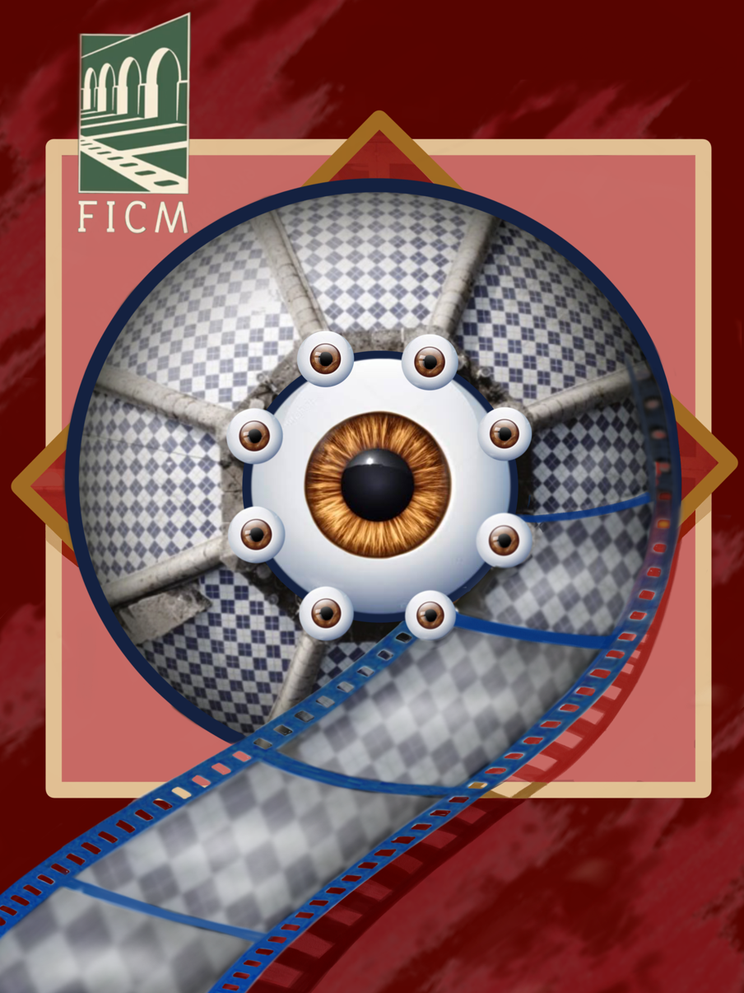

###

Press contact:
Margarita Fink
margarita.fink@moreliafilmfest.com
Cel. 04455-5405-9998
For more information:
www.moreliafilmfest.com
Facebook: moreliafilmfest
Twitter: @FICM
#FICM2019
#MoreliaIsMexicanCinema

