-PRESS RELEASE-

Morelia, Michoacán, June 18, 2019.

**FICM Presents the Image of Its 17th Edition**

The **Morelia International Film Festival** (FICM) explores the Michoacán capital from the heights to celebrate its 17th edition.

Rodrigo Toledo, the creative mind behind the image of the festival, portrayed the city from the sky with the help of drones. The result is a magnificent and unusual face of the Cathedral of Morelia, framed by a dynamic font inspired by the work of Roman Cieślewicz, graphic artist and photographer from Poland.

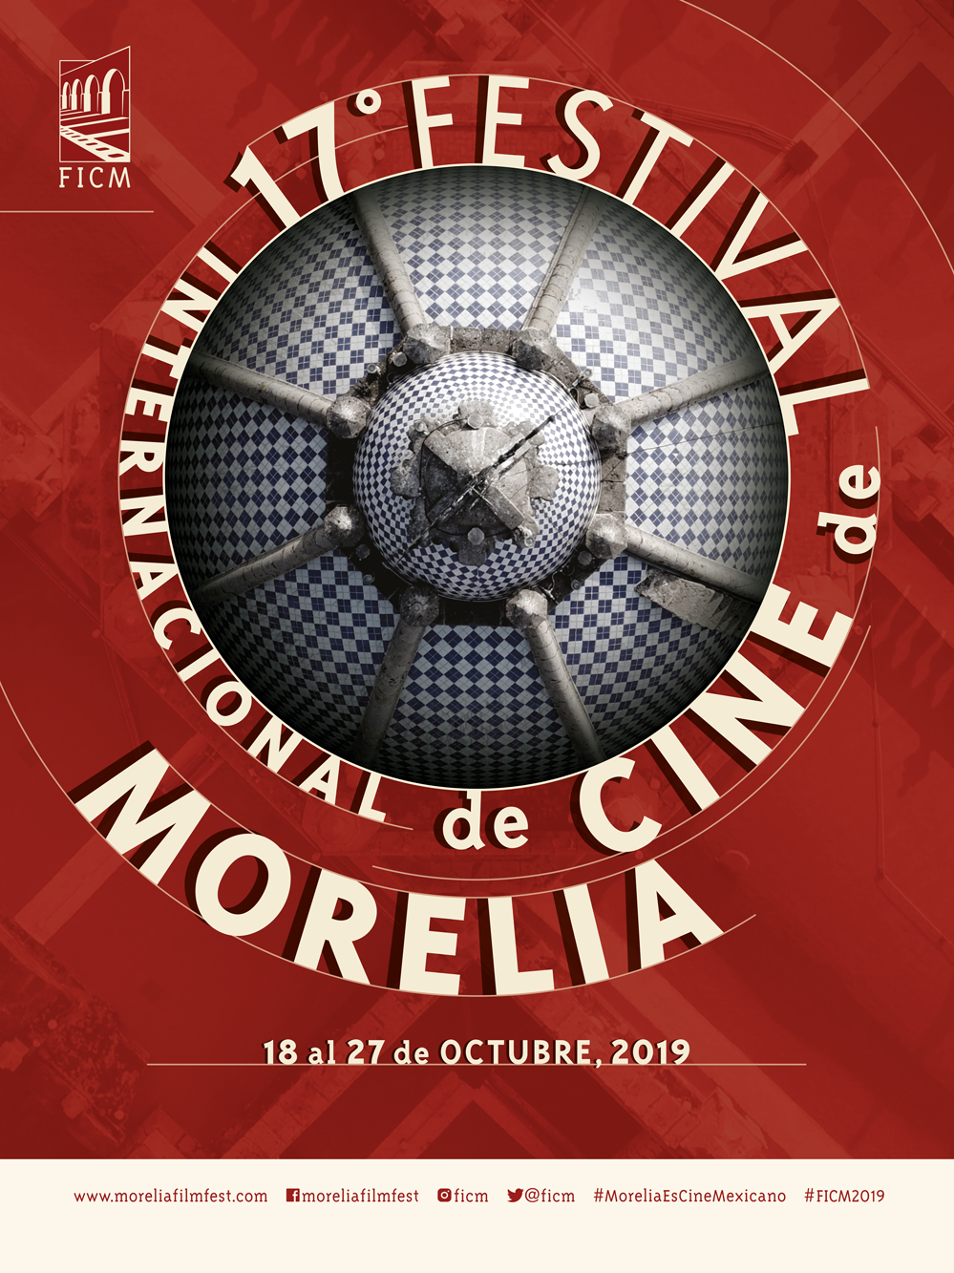

“The dome of the Cathedral may be interpreted as an Ojo, the most important award given by the FICM. Without doing so in an obvious way, that circular form may refer to elements related to cinema, like the roll of a movie,” said Rodrigo Toledo.

MORE INFORMATION

###

**Press contact:**

Margarita Fink

[margarita.fink@moreliafilmfest.com](mailto:margarita.fink@moreliafilmfest.com)

Cel. 04455-5405-9998

**More information:**

[www.moreliafilmfest.com](http://www.moreliafilmfest.com)

Facebook: moreliafilmfest

Twitter: @FICM

#FICM2019

#MoreliaEsCineMexicano