-PRESS RELEASE-

Morelia, Michoacán, September 14th, 2018.

Impulso Morelia 4 Announces the Selected Projects

- Nicolas Philibert (France), Josué Méndez (Peru) and Mirsad Purivatra (Bosnia-Herzegovina) will make up the international jury.

The Morelia International Film Festival (FICM) is pleased to announce the titles selected to participate in Impulso Morelia 4, the festival’s section that since 2015 showcases Mexican features films in diverse stages of editing and post-production, in the aim of establishing a constructive dialogue about the proposals and offer them international visibility.

Impulso Morelia 4 selected projects are:

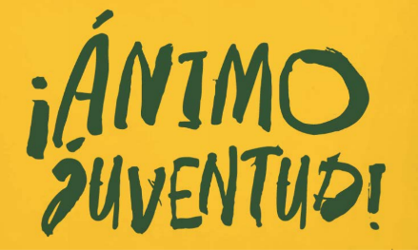
Go Youth! (fiction)
Dir. Carlos Armella | B Positivo Producciones

Four youths try to find themselves in an adult world —love, crime, acceptance and isolation are some of the monsters they will face.

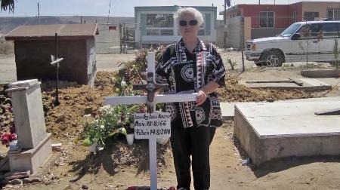

Comala (documentary)
Dir. Gian Cassini | Imagyx Entertainment

A man reencounters his family and his father’s ghost, a hit man murdered years ago, after his brother’s disappearance.

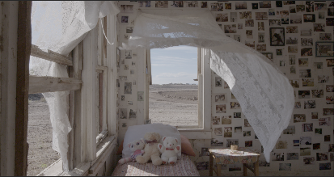
The Guardian of Memory (documentary)
Dir. Marcela Arteaga | Gefilte Films

The story of Carlos Spector, a migratory attorney based in Texas, whose job is to fight for political asylum of Mexicans who run away from violence and oblivion.

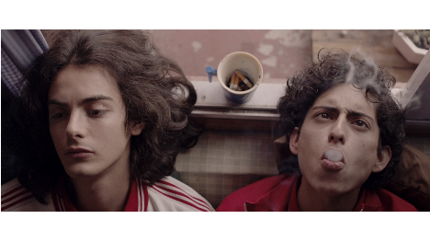

This is not Berlin (fiction)
Dir. Hari Sama | Catatonia Cine

A maladjusted teenager finds himself in the world of nightlife, punk music, drugs and sex in 1980’s Mexico City.

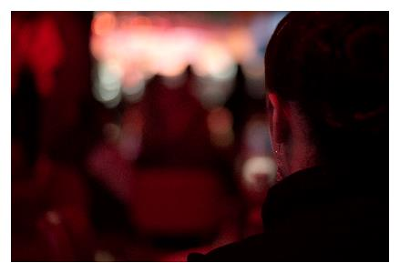
La Mami (documentary)
Dir. Laura Herrero Garvín | Cacerola Films

The life of a Mexico City cabaret is embodied in “La Mami”, a woman in charge of cleaning the bathrooms and taking care of the women who work there night after night.

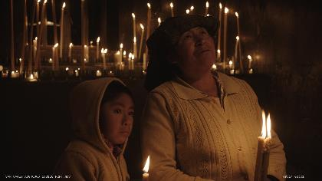
Sanctorum (fiction)
Dir. Joshua Gil | Parábola Cine

In a town devastated by drug war and violence, a boy has lost his mother; his grandmother has told him she might come back by a miracle.

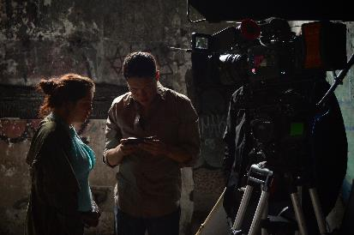
Three-Body Problem (ficción)
Dir. Carlos Lenin Treviño Rodríguez | UNAM-CUEC & IMCINE-FOPROCINE

A couple whose love is ending inhabit a nostalgic world, in an industrial and abandoned neighborhood.

The films will be screened exclusively for national and international festival programmers, producers, distributors and sales agents, as a unique opportunity aimed at shared reflection and the conclusion, promotion and circulation of the proposals. Impulso Morelia 4 will be held October 24th through 26th 2018, during the 16th edition of the Morelia International Film Festival.

Awards

Curated by José María Riba, Impulso Morelia 4 grants important awards, in kind and in cash, to the selected proposals:

- A cash incentive of $200,000 MXN destined to post-production processes and services will be bestowed by the Morelia International Film Festival to one of the participating titles.
- The company Cinépolis Distribución will offer one of the films a guarantee for national distribution, with terms that will be defined in agreement with the selected film.
- Ambulante participates with an award of $50,000 MXN in cash to complete the post-production of a documentary feature. The winning film will have a special screening in the next edition of Ambulante Film Festival Tour
- Estudios Churubusco Azteca will award one project with $200,000.00 MXN in post-production and TXH sound services.
- The prestigious post-production studio Splendor Omnia will give an award consisting in a week of sound mix and another one of color correction.

Jury

The jury in charge of selecting the winner will be composed of Nicolas Philibert (France), Josué Méndez (Peru) and Mirsad Purivatra (Bosnia-Herzegovina).

Nicolas Philibert. He is one of the world’s most prominent documentary filmmakers. He studied philosophy and began his career as an assistant to René Allio and Alain Tanner. In 1978, he co-directed his first feature-length documentary, La voix de son maître, with Gérard Mordillat. His work has been a powerful influence on the documentary genre ever since. His films include La Ville Louvre, Le pays des sourds, La moindre des choses, the widely successful Être et avoir, Nénette, and La maison de la radio. De chaque instant, his latest film, will be screened at the 16th FICM.

Josué Méndez. He has written and directed the films Days of Santiago (the most award-winning Peruvian film in history, premiered in competition at the International Film Festival Rotterdam) and Gods, premiered in Locarno Festival; he has also worked in the production of Paradise, The Bad Intentions, Oliver’s Deal, and Icaros: A Vision. In Peru, he has directed in television, advertising, and theater. He has worked as a co-showrunner, co-producer, and co-screenwriter on the series El Chapo and is currently co-writing the series Tinta roja. He is also working on his third feature-length film as director: Ronnie Monroy ama a todas. He is the artistic director of the Lima Film Festival and a Rolex Arts Fellow.

Mirsad Purivatra. He founded and directs the Sarajevo Film Festival. As the director of the Obala Art Centar, Mirsad worked on the production of works for the stage, participating in distinguished international theatre festivals in the late 80’s. In 1995, Obala founded the Sarajevo Film Festival under his direction, an initiative that has become one of the most influential film festivals in Europe and the leading festival in Southeast Europe. Mirsad’s other professional roles have included serving as the director of B&H Soros Open Society Fund, as the director of Bosnia-Herzegovina Radio and Television, and as the general director of the B&H branch of the McCann Erickson marketing agency. As a producer or co-producer, he has participated in Once Upon a Time in Anatolia, directed by Nuri Bilge Ceylan (winner of the 2011 Cannes Jury Prize); Sieranevada, directed by Cristi Puiu (Cannes Competition 2016); and The Wild Pear Tree, directed by Nuri Bilge Ceylan (Cannes Competition 2018).

###

Contacto de prensa:
Margarita Fink
margarita.fink@moreliafilmfest.com
Cel. 04455-5405-9998
Para más información:
www.moreliafilmfest.com
Facebook: moreliafilmfest
Twitter: @FICM

