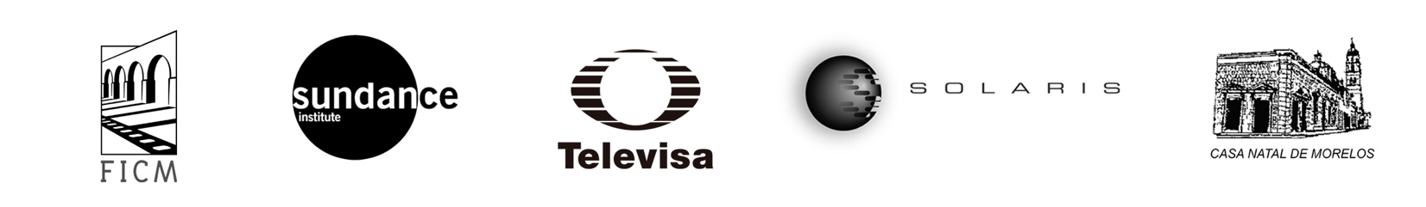

-PRESS RELEASE-

Morelia, Michoacán, October 2, 2017.

MORELIA SUNDANCE Screenplay Lab
with the collaboration of Bertha Navarro

In partnership with the Sundance Institute and its international program to promote feature films, the Morelia International Film Festival (FICM) will carry out, for the first time, a lab for perfecting movie screenplays that looks to enhance and enrich its training activities directing them to Mexican filmmakers. The lab will be held from October 17 to 21, 2017, at the 15th edition of FICM.

The MORELIA SUNDANCE Screenplay Lab has the invaluable collaboration of Marina Stavenhagen and renowned Mexican filmmaker Bertha Navarro, producer of iconic American films such as Reed: México Insurgente (1973) Cabeza de Vaca (1991), Cronos (1993), The Devil's Backbone (2001) and Pan's Labyrinth (2006), among many others. Bertha Navarro is a pioneer in Mexico for the realization of workshops with the objective to raise the quality of the screenplays that are produced in Spanish.

For more than 30 years, the international program of the Sundance Institute has supported emerging filmmakers around the world, encouraging the creation of independent projects from the stage of development and writing to realization, postproduction, and distribution. Allied to several organizations supporting or training film in different countries, the Sundance Institute promotes an intercultural dialogue and the rigor of work in creative processes.

At the MORELIA SUNDANCE Screenplay Lab, an international group of filmmakers, producers, and film writers will work closely and personally for four days with selected Mexican filmmakers and writers. This first workshop will have as creative advisors:

- Dante Harper: Producer, director and film writer. He is best known as the screenwriter of Edge of Tomorrow (2014), directed by Doug Liman. He has recently collaborated with David Fincher, Roland Emmerich, Marc Foster and Ridley Scott.

- Naomi Foner: Writer, producer, and director. Her work Running on Empty (1988), directed by Sydney Lumet, was nominated for an Oscar for Best Original Screenplay and received the PEN West Award and Golden Globe. She wrote and produced the films A Dangerous Woman (1993), Losing Isaiah 1995), Bee Season (2005) and Very Good Girls (2013). She has taught at Columbia University, UCLA, and USC film schools.

- Erik Jendresen: Producer, writer, and showrunner, has written numerous television series in the United States, among them the winner of the Golden Globe, Band of Brothers (2001). In cinema, his most recent project was Ithaca (2015) with Meg Ryan, Tom Hanks, and Sam Shepard.

- Carlos Cuarón: Mexican writer, director, and producer. He has directed Rudo y Cursi (2008) and Besos de azúcar (2013), as well as numerous short films. As a writer, the movies El misterio de trinidad (2003), Sólo con tu pareja (1991), Y tu mamá también (2001) stand out; the latter nominated for an Oscar and BAFTA awards and winner of the Silver Lion for Best Screenplay at the Venice Film Festival.
The projects and filmmakers selected to participate in the first edition of MORELIA SUNDANCE Screenplay Lab are:
- Buchinos, by Betzabé García.
- Noche de fuego, by Tatiana Huezo
- Los amantes se despiden con la mirada, by Rigoberto Perezcano
- Mano de obra, by David Zonana

The first edition of the SUNDANCE MORELIA Screenplay Lab will be possible with the valuable support of Televisa. FICM also extends its gratitude to Juan Pablo Arroyo for the loan of the facilities where the workshop will take place, as well as the Casa Natal Museum of Morelos where some screenings will take place.

###
Press contact:
Margarita Fink
margarita.fink@moreliafilmfest.com Cel. 04455-5405-9998

More information:
www.moreliafilmfest.com
Facebook: moreliafilmfest
Twitter: @FICM
Instagram: FICM
#15FICM

