-PRESS RELEASE- Morelia, Michoacán, October 11, 2017.

Special screening of Los motivos de Luz
by Felipe Cazals at the 15th FICM

The Morelia International Film Festival (FICM) has always been known for celebrating the diversity and richness of Mexican cinema: both by supporting new talent and by showing movies that showcase our country's cinematographic tradition. In this spirit, it is a privilege for the festival to show on its fifteenth anniversary a masterpiece by Felipe Cazals: Los motivos de Luz (1985).

The 15th FICM will also be honored to have the presence of Felipe Cazals, who will be in Morelia to present the gala screening of his film on Tuesday, October 24, at 20:30 hrs.

One of the most outstanding filmmakers in Mexico, Cazals has been recognized with the Salvador Toscano Medal for Film Merit of the Cineteca Nacional, with the National Prize of Sciences and Arts, and the UNAM's Film Archive Medal, among other awards. He was one of the founders of the Independent Cinema of Mexico group and has directed fundamental titles of Mexican cinema like Canoa (1975), El apando (1975) and Las Poquianchis (1976), among others. He has been an active member of the Mexican Academy of Cinematographic Arts and Sciences since 1998.

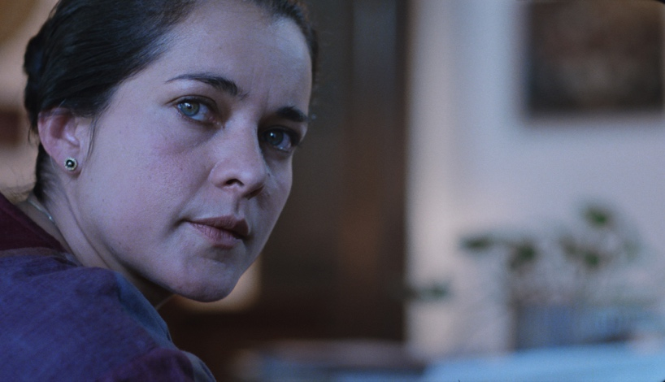

WATCH TRAILER

Based on a true police case, Los motivos de luz is the portrait of a woman in jail, accused of murdering her children. The husband and mother-in-law claim that she killed them premeditatedly. Dr. Rebollar intends to help the woman, but she does not remember anything and thinks that the prison is purgatory: a previous stage before arriving to heaven.

Winners of the Ariel Award for Best Actress (Patricia Reyes Spíndola) and Best Supporting Actress (Ana Ofelia Murguía) in 1986; of the Diosa de Plata award to Best Actress (Patricia Reyes Spíndola), Best Supporting Actress (Ana Ofelia Murguía) and Best Actor (Carlos Cardán) in 1986; and winner of the Concha de Plata at the San Sebastian Film Festival of 1985; Los motivos de Luz is an unmissable film to understand the history of national cinema.

###
Press contact:
Margarita Fink
margarita.fink@moreliafilmfest.com
Cel. 04455-5405-9998

More information:
www.moreliafilmfest.com
Facebook: moreliafilmfest
Twitter: @FICM
#15FICM

