-PRESS RELEASE- Morelia, Michoacán, October 9, 2017.

Ana and Bruno will be
the closing film at the 15th FICM

The fifteenth edition of the Morelia International Film Festival (FICM) will close with the animated film Ana and Bruno, by the director Carlos Carrera. After its successful international premiere at the Annecy International Animated Film Festival in France, the most internationally recognized animation festival, Ana and Bruno will have its Latin American premiere in Morelia on October 28, 2017. The money raised by this screening will be donated in full to the victims of the recent earthquakes in Mexico through the Fuerza México Trust.

Ana is a curious girl who escapes from a psychiatric clinic in search of her father to save her mother. With the help of strange and funny fantastic beings, whom she meets in that place, she embarks on a journey full of exciting and moving adventures. Based on Daniel Emil's novel Ana. The voices of the characters are interpreted by Galia Mayer, Silverio Palacios, Marina de Tavira, Damián Alcázar, Héctor Bonilla, Regina Orozco and Daniel Carrera Pasternac, among others.

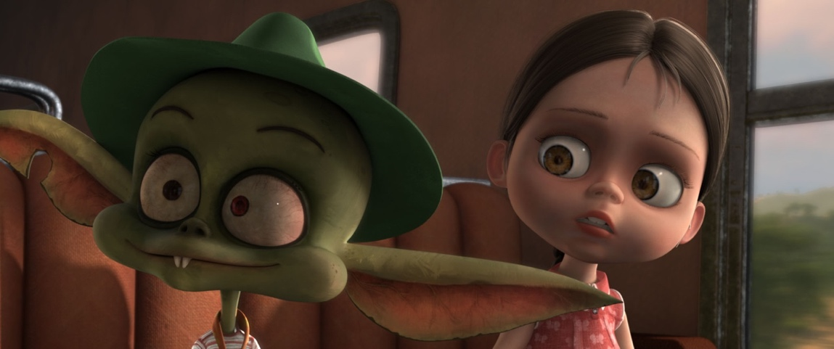

WATCH THE TRAILER

Carlos Carrera is one of the most celebrated Mexican directors. He won the Palme d'Or at the Cannes Film Festival with the animated short film El héroe (1994); has directed nine animated short films and seven live-action feature films, one of which was nominated for an Oscar for Best Foreign Language Film in 2002 and was the highest grossing movie in Mexican film history for over 10 years.

About Ana and Bruno, his first feature film, Carlos Carrera stated: “Animation provides you with the freedom to embrace stories from the direct language of imagination, the approach to human emotions and realistic gestures can be equally represented as the defiance to natural laws within the same narrative logic. Ana y Bruno tells the story of broken and then restored family bonds through a fantasy and adventure tale with touches of humor. The real and imaginary worlds interlace causing a mutual impact.”.

For FICM, it is a matter of joy to close its fifteenth edition with Ana and Bruno, a film that even before its commercial release is already a reference in the history of Mexican animation.

###
Press contact:
Margarita Fink
margarita.fink@moreliafilmfest.com
Cel. 04455-5405-9998

More information:
www.moreliafilmfest.com
Facebook: moreliafilmfest
Twitter: @FICM
#15FICM

