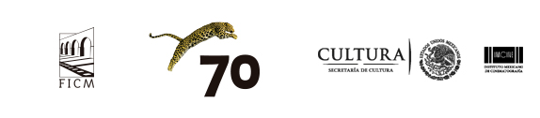

-PRESS RELEASE- Morelia, Michoacán, September 29, 2017.

Locarno Industry Academy International Morelia – IMCINE
reveals its participants

The Morelia International Film Festival (FICM) is pleased to announce the participants of the Locarno Industry Academy International Morelia – IMCINE workshop, which will take place during the 15th FICM from October 21st to 25th.

The workshop is an initiative organized by FICM with the Festival del film Locarno and the Mexican Film Institute (IMCINE). Its goal is to support young industry professionals working in the areas of sales, marketing, online and traditional distribution, exhibition and programming, to understand the challenges of the independent film industry in Latin America and the world.

Now open to non-Mexicans participants from Latin America and abroad, the Academy will welcome eight young professionals from very various backgrounds, working in exhibition, traditional and online distribution, and festival programming. The five-day workshop will be designed and run by Sandra Gomez (distributor and producer at INTERIOR XIII) and Marion Klotz (Industry Academy International project manager).

The 2017 participants are:

- Angela Guerrero Arias (Canana, México)
- Andrés Jiménez Suárez (FICCI, Colombia)
- Tomás Astudillo (Vaivem, Ecuador)
- Adriana Agudelo Moreno (Mutokino, Colombia)
- Lariza Melo Preciado (IMCINE, México)
- Edher Campos (Machete, México)
- Diego Alfonso Torres Méndez (Cine Móvil Toto, México)
- Regina Serratos Varela (Piano Distribución, México)

More details about the program and speakers will be announced soon.
Press contact:
Margarita Fink
margarita.fink@moreliafilmfest.com
Cel. 04455-5405-9998

More information:
www.moreliafilmfest.com
Facebook: moreliafilmfest
Twitter: @FICM
#15FICM

