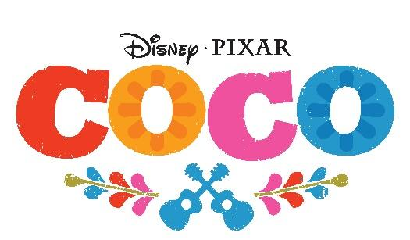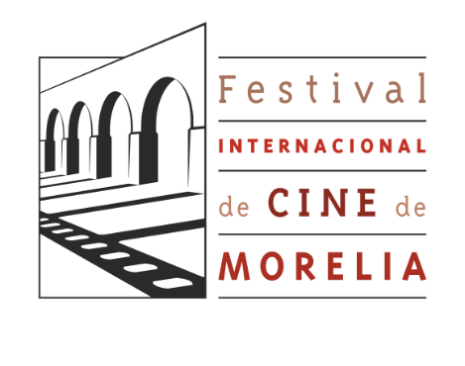

COCO, THE NEW DISNEY•PIXAR MOVIE, WILL OPEN THE 15º MORELIA INTERNATIONAL FILM FESTIVAL

This will be the first time ever that the Festival opens with an animated film

Mexico City, July 5, 2017. COCO, the new Disney•Pixar production, will be screened for the first time during the opening event of Morelia International Film Festival (FICM) on October 20, 2017, as part of its 15º anniversary celebration (#15FICM).

It is the first time the Festival, which will take place from October 20 to 29 at the City of Morelia (Michoacán), will open with an animated movie.

Inspired by Mexico’s people and rich culture, Disney•Pixar’s COCO is a new original story that pays homage to “Día de Muertos,” a tradition whose annual celebration in Morelia is renowned.

Despite his family’s baffling generations-old ban on music, Miguel dreams of becoming an accomplished musician like his idol, Ernesto de la Cruz . Desperate to prove his talent, Miguel finds himself in the stunning and colorful Land of the Dead following a mysterious chain of events. Along the way, he meets charming trickster Hector (voice of Gael García Bernal), and together, they set off on an extraordinary journey to unlock the real story behind Miguel's family history.

COCO is directed by Lee Unkrich (“Toy Story 3”), co-directed by Adrian Molina (story artist “Monsters University”) and produced by Darla K. Anderson (“Toy Story 3”). Disney•Pixar’s COCO opens in Mexico on October 27th, 2017, one month before the rest of the world.

For more information:

International Film Festival of Morelia
www.moreliafilmfest.com
Facebook: moreliafilmfest
Twitter: @FICM
Instagram: FICM
#15FICM
Disney Studios LA
Facebook: https://www.facebook.com/DisneyStudiosLA
Twitter: https://twitter.com/DisneyStudiosLA
Instagram: https://instagram.com/DisneyStudiosLA

COCO
See the trailer: https://www.youtube.com/watch?v=7l8sp-Ra8_0

#PixarCocoMX

About Walt Disney Studios Motion Pictures
Walt Disney Studios Motion Pictures is part of The Walt Disney Company, aiming to produce and distribute films under the following names: Walt Disney Pictures, Walt Disney Animation Studios, Disney∙Pixar Animation Studios and DisneyToon Studios, as well as Touchstone Pictures. Walt Disney Studios Motion Pictures International is the international studies’ distributor. Walt Disney Studios Home Entertainment distributes Disney and others movies among DVD and Blu-rayTM rental and sale market worldwide. Disney Theatrical Productions is one of the greatest Broadway musicals producers and Disney Music Group distributes the original movies soundtracks through its record companies: Walt Disney Records and Hollywood Records.

PRESS CONTACT

INTERNATIONAL FILM FESTIVAL OF MORELIA
Margarita Fink
5207 9397 ext. 104
margarita.fink@moreliafilmfest.com

THE WALT DISNEY COMPANY MEXICO
Montserrat Arenas
52 61 01 48
montserrat.arenas@disney.com
Elsie Salcedo
52 58 19 02
elsie.x.salcedo.-nd@disney.com

